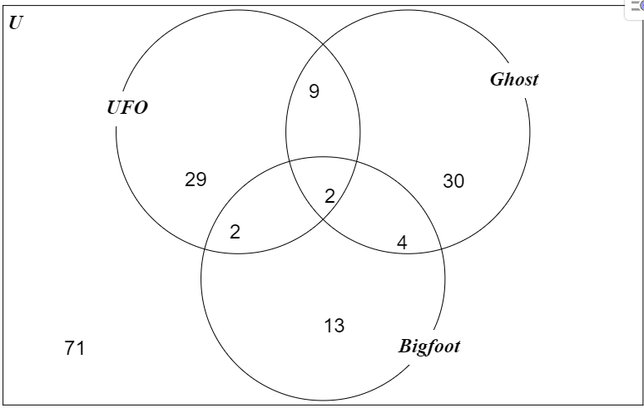

Number of people believed in at least one
= 29 + 9 + 2 +2 + 30 + 4 + 13 = 89

